Minutes of the Annual Assembly Meeting for the Parish of Tibshelf held on Tuesday 14th May 2024 at 7pm in Tibshelf Village Hall

Minutes
Present: Cllr A Beckett, Cllr L Kingscott, Cllr S Wood, Cllr J Gilbody, Cllr M Watkinson, Cllr H Varney, Cllr M Ward, Cllr R Vaughan
In attendance: R Tattershaw – Parish Clerk, Wendy Amis, Chief Officer DALC and 7 members of the Parish.

Prior to the start of the meeting, Wendy Amis, Chief Officer of Derbyshire Association of Local Councils (DALC) presented Tibshelf Parish council with the Local Council Award Scheme Foundation Award.

- Appointment of Clerk to the meeting.
It was moved by Cllr Beckett, seconded by Cllr Wood and resolved unanimously to nominate the Tibshelf Parish Clerk to clerk the meeting.

- To confirm the minutes of the Annual Assembly Meeting held on the 16 May 2023 as a correct record.
It was moved by Cllr Wood, seconded by Cllr Kingscott and resolved unanimously to accept the minutes as an accurate record.

- Annual Budget and Precept for the Financial Year April 2024 to March 2025.
The Clerk read out the Annual Budget and Precept information for the financial year April 2024 to March 2025 - See attached report from the Parish Clerk and R.F.O (Appendix 1).

- Annual Parish Council Report.
Cllr Allison Beckett (Chair) read out Annual Parish Council Report - see attached report from the Chairman of Tibshelf Parish Council (Appendix 2).

- Local Group Reports.
Ivan Brentnall delivered a report on behalf of Tibshelf Historical Society covering the following:
- Thank you to the Parish Council for their support.
- Membership of 85 - as of February 2024.
- Current annual membership fee of £5.00.
- 3000 Facebook followers.
- Website in place.
- 2 Years ago they started a ‘living memory’ scheme where they give local history talks in local villages.
- Approx 45-50 people attend meetings.
- They’ve secured Community Lottery Funding of £15,000 for a 2nd scheme that will include crafting activities – willow making, collaging.
- The annual accounts have passed the audit.
- Their Miners to Medics project put Tibshelf on the map.
- They have 78 leaflets available on Tibshelf History.
- They will be applying for further Heritage funding in the next few years.

Deborah Watson delivered a report on behalf of The Green Bunch covering the following:
- Founded in 2019 as they recognised the benefits of horticulture to the village.
- The flower bed in the Co-op car park was the first project.
- They completed 7 platinum jubilee planters to recognize the decades of the queen’s reign.
- They have planted the new planter at the Village Hall with a mix of perennials and evergreens – currently only half planted.
- Ask to be informed of any bulb gaps in the village and asked people to contact them if they’d like to become involved.
- They will be planting the 4 village boundary planters again this year.
- They hope to plant sunflowers in the Christmas tree planter in the center of the village.
- A plant sale will be held on the 22^{nd of} June 2024.
- They will be running a Tibshelf in Bloom competition.

Mark Scarborough delivered a report on behalf of Tibshelf Neighbourhood Watch Scheme – report attached (Appendix 3).

Lian Kingscott delivered a report on behalf of Tibshelf Scouts and Guides covering the following:
- Guides for girls aged 4-18 years.
- Scouts for boys and girls aged 4-18 years.
- They re-opened the Scouts section in the last 12 months (closed since Covid). This is for 10–14-year-olds and is currently full.
- They also Rangers and this is also currently full.
- They would appreciate support with light maintenance jobs, and they require more volunteers for the guides group.

Cllr Sue Wood delivered a report on behalf of the Warm Bank and Social Group.
The Warm Bank runs from October to April
- Tuesday afternoons 12.30 to 3pm.
- Originally started by Cllr Wood, Cllr Beckett, and Cllr Kingscott, but is now run by Cllr Wood and a team of volunteers.
- Hot food and tea and biscuits.
- Donations received by the Freemasons and a grant from Derbyshire County Council.
- 25-30 Regular attendees.
- Regular guest speakers incl: Citizens Advice, Energy advice, Cyber security, benefits advice.
The Social Group runs May to September - Tuesday afternoons 12.30 to 3pm.

Allison Beckett delivered a report on Tibshelf Community Association
- Members: Allison Beckett, Lian Kingscott, Sue Wood and Justin Gilbody.
- Run the annual parish carnival but would like to ask the Parish Council to takeover running this event – to be held 17th August 2024.
- Jointly hosted the 2023 fireworks event with the Parish Council.

Allison Beckett delivered a report on behalf of Tibshelf Food Bank
- Run by Allison Beckett and Lian Kingscott
- Started in 2020.
- Supported 150 families – still a need in the village.
- Delivered shopping during Covid.
- Received grants from Arnold Clarke.
- The Parish Council support via free use of the pavilion.

Sue Wood delivered a report on behalf of Kids Activities
- Started 5 years ago with the support of £1,000 from the Parish Council.
- Now sustains itself through fund raising.
- Activities include crafts, cake making, discos, Easter, and Xmas events.
- A breakfast club is to be held on the 6th and 13th August between 8am and 11am – a donation has been received of £250 to support this event.

Pete Ward delivered a report on behalf of Tibshelf Band
- Formed in 2016.
- They have received grants from the Parish Council.
- Support to village events and a few higher profile jobs are now starting.
- Free membership and open to all.
- Train in the Village Hall on a Thursday evening.
- Currently have 28 members.
- 8 Members of the training band – age range 8-82.
- Instruments may be provided.
- Recently did a D Day 1940’s re-enactment event in Melton Mowbray.
- They have been asked to play in Chatsworth Gardens.
- They did an Umpah themed night and a Carol Concert for the Parish Council.

Sarah Byard delivered a report on behalf of The Allotment Society – report attached (Appendix 4).

- To consider any other Parish matter that may be brought forward by the Council or local government electors.
- Cllr Sue Wood wished to thank Wayne Kingscott for his support as a volunteer running the Village Hall bar, and the Clerk and Admin Asst for their hard work.

- Cllr Allison Beckett wished to thank the Councillors for their work and support in the last year.

- CPR and Defib presentation
Jan Ward sent her apologies as she was unable to attend due to last-minute work commitments.

The meeting closed at 8.25pm.

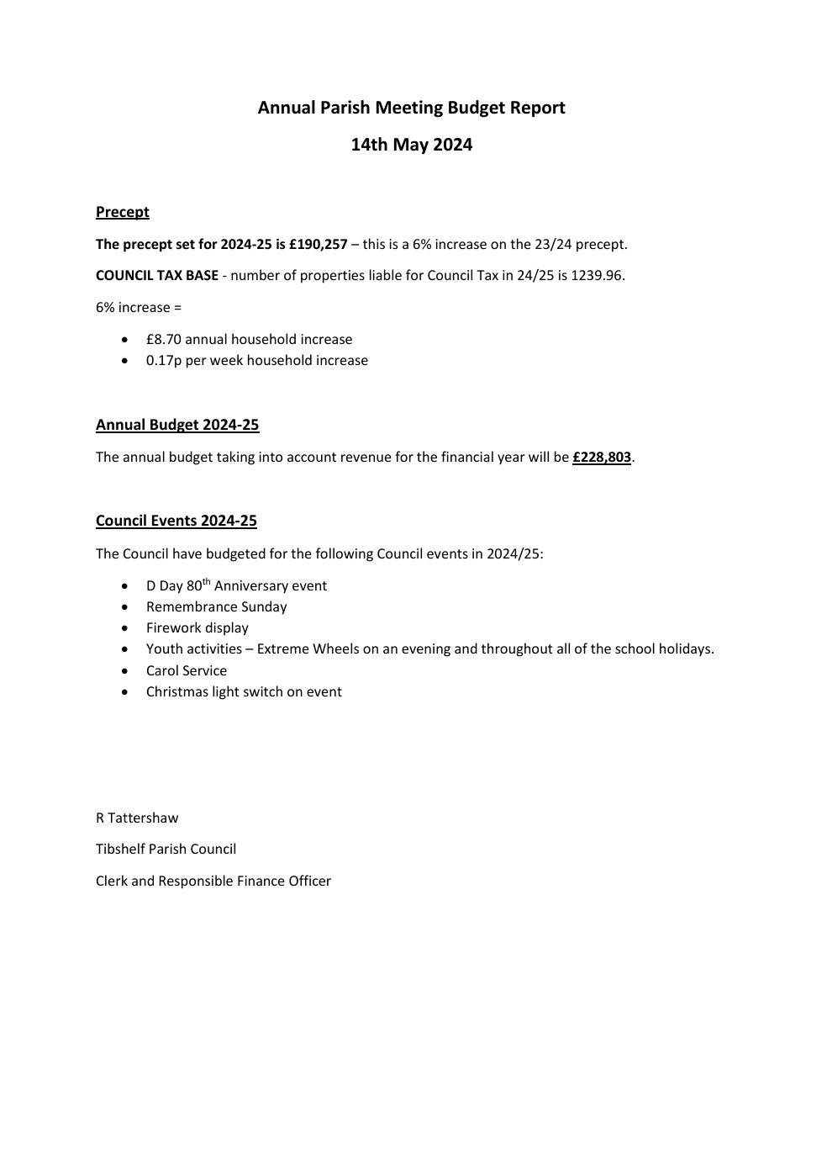
Appendix 1
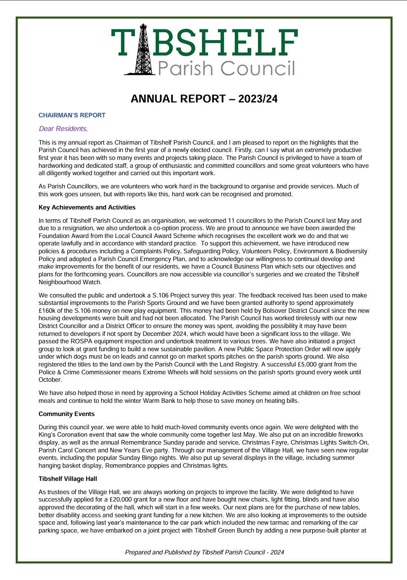
Appendix 2
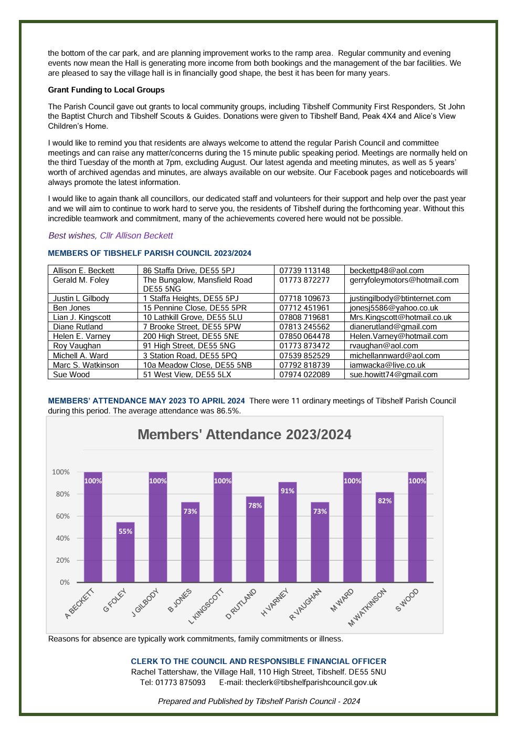
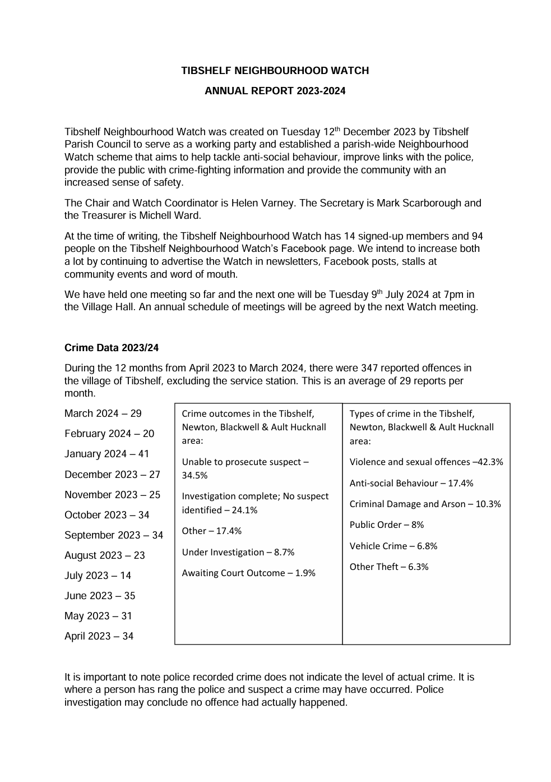
Appendix 3

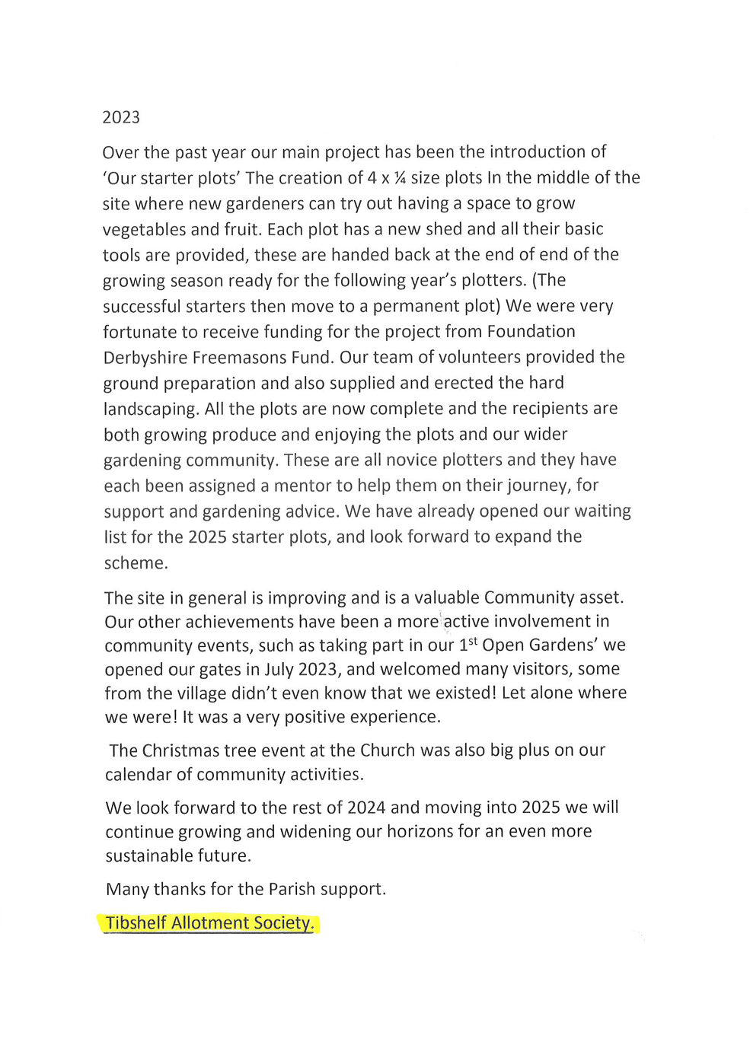
Appendix 4

